IDH28
Integrated pulse typeopenRing Stepper Driver

User Manual V1.0.0

Table of contents
one,Product Introduction - 1 -
1.1 Product Overview - 1 -
1.2 Product Features - 1 -
1.3 Application Areas - 1 -
1.4 Naming conventions - 2 -
two,Electrical, Mechanical and Environmental Specifications - 3 -
2.1 Mechanical installation diagram - 3 -
2.2 Installation Notes - 3 -
2.3 Electrical specifications - 3 -
2.4 Operating environment and parameters - 4 -
three,Driver interface and wiring introduction - 4 -
3.1 Interface Diagram - 4 -
3.2 Interface Description - 4 -
3.2.1 Power input interface - 4 -
3.2.2 Control signal interface - 5 -
3.2.3 Output signal interface - 5 -
3.2.4 RS485 interface - 5 -
3.2.5 Burning and debugging interface - 6 -
3.2.6 Status Indicator - 6 -
3.3 Input control signal - 7 -
3.3.1 Input control signal interface circuit - 7 -
3.3.2 Control signal timing diagram - 7 -
3.3.3 Control signal mode setting - 8 -
3.4 Output control signal - 8 -
3.4.1 Used for alarm and arrival output - 8 -
3.4.2 Used as a brake control motor - 9 -
3.5 Wiring requirements - 10 -
Four,Power supply selection - 10 -
five,Indicator lights and alarm indicators - 11 -
six,Adaptive motor parameters and selection - 12 -
6.1 Motor Appearance Schematic - 12 -
6.2 Motor technical parameters - 12 -
6.3 Motor shaft parameters - 12 -
6.4 Wiring Definition - 12 -
seven,Warranty and after-sales - 13 -
7.1 Warranty - 13 -
7.1.1 Free warranty - 13 -
7.1.2 Warranty exclusion - 13 -
7.2 Exchange - 13 -
7.2.1 Replacement of defective product - 13 -
7.2.2 Exchange for non-product failure - 14 -
7.3 Returns - 14 -
7.4 After-sales service - 14 -
eight,Revision History - 15 -

Product Introduction

1.1 Product Overview
IDH28 integrated pulse open-loop stepper driverIt is a newly launched new type of integrated motor driver. It adopts the latest dedicated motor control digital signal processor to improve the overall performance of the motor, reduce the heating level of the motor and reduce the vibration of the motor. It adopts an integrated design of motor and driver, which makes the installation more compact and reduces external interference.
IDH28With serial port debugging function, communication adopts MINI USB interface. Users can set various parameters such as subdivision, current, working mode, etc. through PC host debugging software, which greatly enriches the practical functions of the product and can meet the application of most occasions.

1.2 Product Features
●Integration of motor and drive saves wiring labor
●Small size, easy to install
●New generation 32-bit DSP technology, good stability, strong compatibility and high cost performance
Optically isolated differential signal input
●Built-in micro-segmentation, excellent low-speed stability
●The impulse response frequency can reach up to 200KHz (higher can be modified)
●Subdivision setting range 200-60000 (can be set by the host computer)
●Precise current control greatly reduces motor heating
●Low vibration and low noise
●With overvoltage, undervoltage, phase loss and other alarm protection functions
Input voltage range:DC12V~40V
●The default effective current is 1.0A (you can also set any current value through the host computer)

1.3 Application Areas
Suitable for various small and medium-sized automation equipment and instruments, such as medical equipment, testing equipment, marking machines, plotters, etc. It meets customers' requirements for low noise, low heat generation, convenient wiring, and stronger anti-interference.

1.4 Naming conventions
The driver model naming rules are as follows:
I DH 28M---
① ② ③ ④ ⑤ ⑥ ⑦ ⑧ ⑨

Serial number | meaning
① | 2-phase/3-phase distinction; Empty: 2-phase drive;
② | General name for product series; I: integrated drive;
③ | Product series number; DH:pulseopenring;
④ | Matching motor base; 28: mainly matching motors with 28 base;
⑤ | The integrated bus series is divided into open and closed loops;
⑥ | With motor or not; M: With motor integrated;
⑦ | Motor body length;
⑧ | Special function code;
⑨ | Design change code;

Electrical, Mechanical and Environmental Specifications

2.1 Mechanical installation diagram
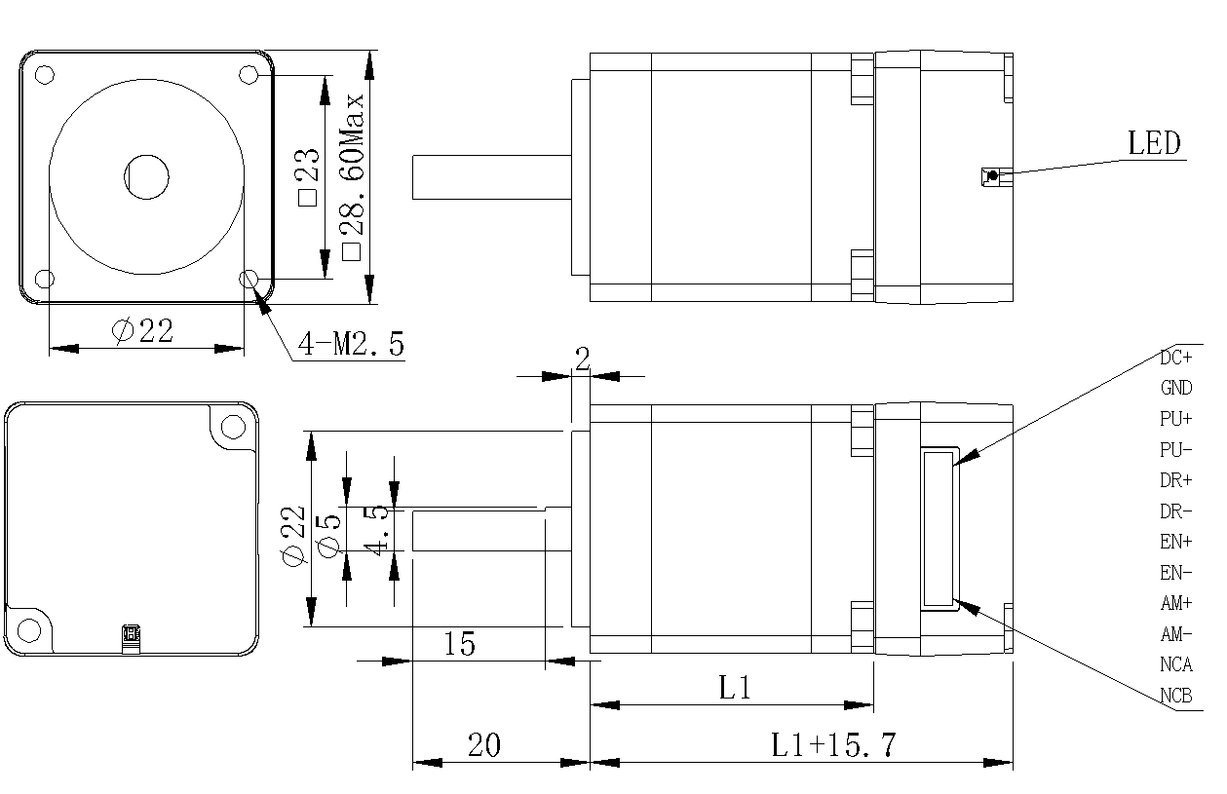
Figure 2.1 Installation dimensions (unit: mm)

2.2 Installation Notes
- When installing the integrated stepper driver, do not knock on the rear end cover of the motor to avoid affecting the operating performance. When designing the installation dimensions, the size and wiring of the wiring terminals must be considered.
- In order to ensure good heat dissipation conditions, a larger installation interval must be reserved as much as possible during actual installation. If multiple integrated drives are installed side by side, fans can be installed to form strong air convection on the surface of the integrated drives to assist in the heat dissipation of the drives and ensure that the drives operate within a reliable operating temperature range.

2.3 Electrical specifications
illustrate | IDH28
illustrate | Minimum | Typical Value | Maximum | unit
Input power voltage | 12 | twenty four | 40 | VDC
Control signal input current | 7 | 10 | 16 | mA
Step pulse frequency | 0 | - | 200 | KHz
Insulation resistance | 50 |  |  | MΩ

2.4 Operating environment and parameters
Cooling method |  | Natural cooling, fan cooling
Usage Environment | occasion | Do not place it near other heating equipment. Avoid dust, oil mist, corrosive gas, high humidity and strong vibration. Flammable gas and conductive dust are prohibited.
Usage Environment | temperature | 0——50℃
Usage Environment | humidity | 40-90%RH
Usage Environment | vibration | 10~55Hz/0.15mm
Storage temperature |  | -20℃~65℃

Driver interface and wiring introduction

3.1 Interface Diagram
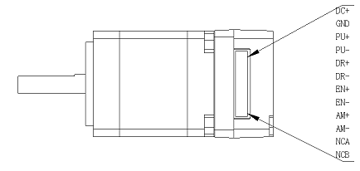
Figure 3.1IDH28Interface Diagram

3.2 Interface Description
IDH28 integrated pulse open-loop stepper driverThe power interface, signal control interface and output signal interface use JST1.25-12P pin socket. The specific definition of the interface is described in the following sections.

3.2.1 Power input interface
name |  | illustrate | Function
VDC | DC+ | Power interface | Power Input  DC12V~40V
VDC | GND | Power interface | Power Input  DC12V~40V

3.2.2 Control signal interface
name | Function
PU+ | Pulse control signal: +5V-+24V can be driven, rising edge is effective, every time the pulse changes from low to high, the motor takes a microstep. In order to reliably respond to the pulse signal, the pulse width should be greater than 2.5μs.
PU-
DR+ | Direction control signal: can be driven by +5V-+24V, high/low level signal. To ensure reliable commutation of the motor, the direction signal should be established at least 50μs before the pulse signal.
DR-
EN+ | Enable control signal: +5V-+24V can be driven, high/low level signal. Used to enable or disable the operation of the motor. When EN+ is connected to +5V and EN- is connected to a low level, the driver will cut off the current of each phase of the motor to put the motor in a free state, and the step pulse will not be responded to at this time. When this function is not needed, the enable signal terminal can be left floating. In addition, the EN terminal can also be used to clear the out-of-tolerance alarm signal.
EN-

3.2.3 Output signal interface
The output signal interface is used as an alarm output function by default. When an overvoltage, undervoltage, or phase loss alarm occurs, the output signal is valid. In addition, the output interface can also be set to the in-position output or brake control output function through the PC host software. Users can make corresponding settings according to actual usage.
name | Function
AM+ | Alarm signal output: When overvoltage, undervoltage, or phase loss alarm occurs, the alarm signal output is valid;  For normally open or normally closed connection, see the description in Section 3.4;  Maximum driving current 50mA.
AM-

3.2.4 RS485 interface
IDH28 integrated pulse open-loop stepper driverThe interface uses the JST1.25-12P pin header, where pins 11 and 12 are defined as 485 communication.

name | Function
NCA | 485 communication interface A terminal; reserved port, this is a pulse type drive, does not support RS485 communication, do not need to connect;
NCB | 485 communication interface B terminal; reserved port, this is a pulse type drive, does not support RS485 communication, do not need to connect;

3.2.5 Burning and debugging interface
IDH28The serial communication interface of the driver adopts MINI USB interface, which can be connected to PC through the dedicated debugging line provided by our company via USB to TTL serial port conversion tool. It is forbidden to plug and unplug under power! On the PC side, customers can set the required parameters, such as current, subdivision, working mode, etc. For details, please refer to the upper computer software interface.
Terminal No. | symbol | name | illustrate
1 | NC | - | Internal Use
2 | NC | - | Internal Use
3 | GND | Serial communication address | 0V
4 | NC | - | Internal Use
5 | NC | - | Internal Use
6 | NC | - | Internal Use
7 | RxD | Serial port receiving end
8 | TXD | Serial port sender
▶Note:IDH28The debugging line connected to the PC is a dedicated line (provided according to user needs). Please check before use to avoid damage.

3.2.6 Status Indicator
IDH28 integrated pulse open-loop stepper driverThe indicator light is a retracted SMD LED, and its basic definition is shown in the following table.
name | Function | illustrate
Green LED | Power supply, parameter saving function indication, factory reset function indication, dial status switching indication,  Alarm indicator light | When the power is on normally, the green light is always on and the red light is off. When saving parameters, restoring factory settings, switching the dial status, or when the device is abnormal, the red and green lights flash alternately to alarm. For the flashing rules, please refer to Chapter 5;
Red LED

3.3 Input control signal

3.3.1 Input control signal interface circuit
IDH28The driver control signal end adopts a differential interface circuit, which is applicable to differential signals, single-ended common cathode and common anode interfaces, and has a built-in high-speed photocoupler, which has strong anti-interference ability in harsh environments. The interface circuit diagram is shown in Figure 3.2.
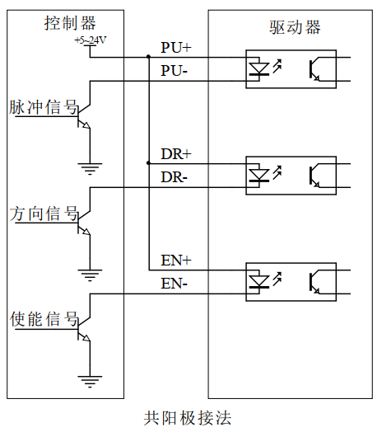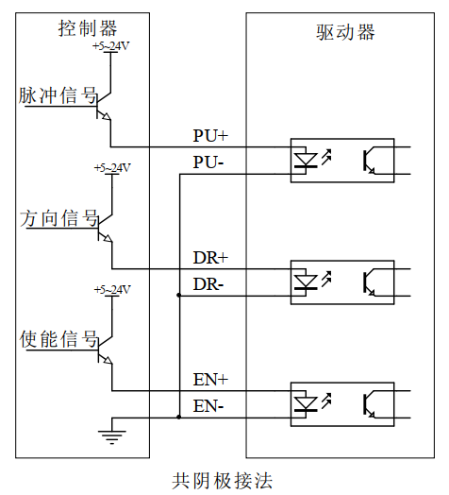
Figure 3.2 Input interface circuit
▶Note:IDH28It is a 5V-24V universal driver, so the signal control end does not need a series resistor!

3.3.2 Control signal timing diagram
In order to avoid some malfunctions and deviations, PU, ​​DR and EN should meet certain requirements, as shown in the following figure:
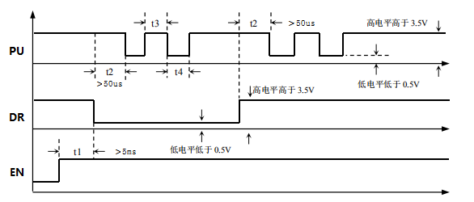
Figure 3.3 Control signal timing diagram
Notes:
- t1: EN (enable signal) should be at least 5ms ahead of DR and confirmed to be high. In general, it is recommended that EN+ and EN- be left floating.
- t2: DR determines its state as high or low at least 50μs in advance of the falling edge of PU.
- t3: The pulse width is at least 2.5μs.
- t4: Low level width is not less than 2.5μs.

3.3.3 Control signal mode setting
Pulse trigger edge selection: The rising edge or falling edge of the pulse can be set to trigger effectively through the PC software.

3.4 Output control signal
After the driver is powered on normally, the effective state of the output interface is initially defaulted to normally open output.The user can also configure the effective state of the output interface through the master station, and the initial default is normally closed output.

3.4.1 Used for alarm and arrival output
The following figure is a wiring diagram for the output signal port when used as an alarm output function (the connection method is the same when used as a position output):
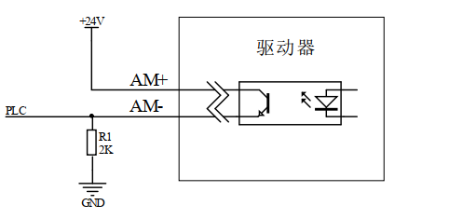
Figure 3.4 Schematic diagram of normally closed connection of output interface
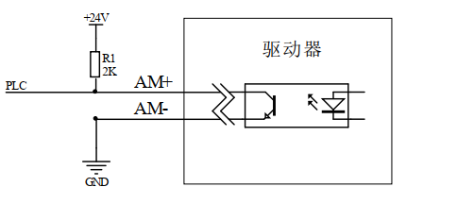
Figure 3.5 Schematic diagram of normally open connection of output interface

3.4.2 Used as a brake control motor
IDH28 integrated pulse open-loop stepper driverThe output port includes the control function of the brake motor brake. The user only needs to set the output port function to 'brake control signal' through the PC host debugging software, and then the brake motor brake can be controlled through the AM+ and AM- ports.
The following figure is a wiring diagram of the brake motor brake device. The relevant parameter descriptions are described in the following table:
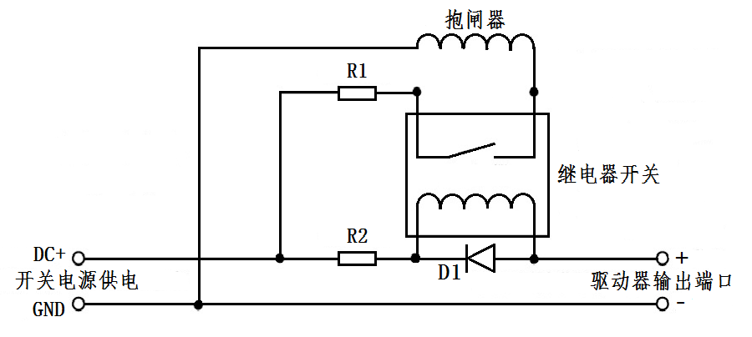
Figure 3.6 Brake motor brake wiring diagram
name | Logo | illustrate
Switching power supply | DC+ | Connect to +24 or +5V power supply
Switching power supply | GND | Ground terminal
Driver output port | AM+ | Output port +
Driver output port | AM- | Output port - end
Protection resistor | R1 | If the brake is powered by DC24V, R1 can be smaller or not connected; if the brake is powered by DC5V, R1 should be larger;
Protection resistor | R2 | R2 can be connected to a 1~2K resistor to limit the current to prevent damage to the optocoupler components inside the driver;  You can refer to the relay specification to determine whether it needs to be connected;
Freewheeling diode | D1 | Protect the internal components of the driver from being damaged by induced voltage. Please refer to the relay specification to determine whether it is necessary to connect;
Brake |  | The control mechanism with brake motor is generally in the release state after the power is turned on, and the motor can run freely. Before use, you need to confirm its power supply voltage to avoid excessive voltage burning the brake device;

3.5 Wiring requirements
- In order to prevent the driver from being interfered, it is recommended that the control signal use shielded cable, and the shield layer is short-circuited with the ground wire. Except for special requirements, the shield line of the control signal cable is grounded at one end: the host computer end of the shield line is grounded, and the driver end of the shield line is suspended. Only the same point is allowed to be grounded in the same machine. If it is not a real ground wire, there may be serious interference. In this case, the shield layer is not connected.
- The pulse and direction signal lines are not allowed to be wrapped side by side with the motor lines. It is best to separate them by at least 10 cm. Otherwise, the motor noise will easily interfere with the pulse direction signals and cause inaccurate motor positioning, system instability and other faults.
- If one power supply supplies multiple drives, they should be connected in parallel at the power supply. Chain connection from one drive to another is not allowed.
- It is strictly forbidden to plug or unplug the high-voltage terminals of the driver while it is powered on. When the motor is stopped, there is still a large current flowing through the coil. Plugging or unplugging the terminals while it is powered on will cause a huge instantaneous induced electromotive force that will burn out the driver.
- It is strictly forbidden to connect the wire end to the terminal after tinning it, otherwise the contact resistance may increase and the terminal may be damaged by overheating.
- The wiring ends must not be exposed outside the terminals to prevent accidental short circuits and damage to the driver.

Power supply selection
The power supply voltage can work normally within the specified range.IDH28The driver is best powered by a regulated DC switching power supply, and it should be noted that the output current range of the switching power supply must be set to the maximum. An unregulated DC power supply can also be used, but it should be noted that the peak value of the voltage ripple after rectification should not exceed the maximum voltage specified. It is recommended that users use a DC voltage lower than the maximum voltage to avoid grid fluctuations exceeding the driver voltage operating range.
▶Note:
- When wiring, pay attention to the positive and negative poles of the power supply and do not connect them in reverse;
- When wiring, pay attention to the position of the power interface and do not connect it to the motor port. After connecting, it is best to confirm whether it is connected correctly;
- It is best to use a regulated DC switching power supply;
- When using an unregulated DC power supply, the power supply current output capacity should be greater than 60% of the driver set current;
- When using a regulated DC switching power supply, the output current of the power supply should be greater than or equal to the operating current of the driver;
- To reduce costs, two or three drivers can share one power supply, but the power supply must be large enough.

Indicator lights and alarm indicators
IDH28 integrated pulse open-loop stepper driverThere is a green LED and a red LED. One can be used as a power indicator, and the other can be used as a fault indicator, a DIP switch indicator, or a parameter save or restore indicator. The specific relationship is shown in Table 6.1 below:
When the driver is powered on, the green LED is always on, and when the driver is powered off, the green LED is off.
When the drive fails, the red and green lights flash alternately, and different flashing patterns indicate different fault information. When the fault is eliminated by the user, the green LED remains on and the red LED goes out.
When saving/restoring parameters, the red and green lights flash alternately in a cycle. When saving/restoring parameters is completed, the green LED is always on and the red LED is off.
Table 6.1 LED status indication
Number of LED flashes |  | Phenomenon | illustrate
Green LED | Red LED | After the green light flashes, the red light flashes
0 | - | Green light is always on, red light is off | Driver Enable
1 | - | Green light flashes, red light off | Receive pulse signal
2 | 1 |  | Pulse received in disabled state
1 | 4 |  | Overpressure alarm
2 | 4 |  | Undervoltage alarm
1 | 6 |  | AB phase loss alarm
2 | 6 |  | Only A phase missing alarm
3 | 6 |  | Only phase B is missing.
1 | 2 |  | Restoring parameters
2 | 2 |  | Saving parameters in progress

Adaptive motor parameters and selection

6.1 Motor Appearance Schematic
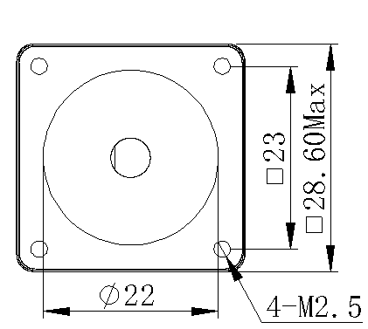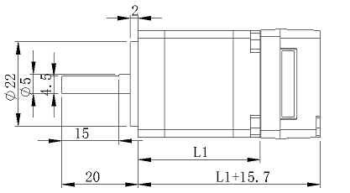
Figure 6.1IDH28Schematic diagram of the appearance of the series of integrated machines

6.2 Motor technical parameters
model | Keep  Torque(mN.M) | Phase current  (A) | resistance  (Ω) | inductance  (MH) | Rotation  Inertia (g.cm2) | Motor  Length L1  (mm) | Tail cover  length  (mm) | weight  (Kg) | Line number
IDH28M-32 | 60 | 1.5 | 1.00 | 1.0 | 9 | 32Max. | 15.7 | 0.12 | 4
IDH28M-42 | 95 | 1.5 | 1.45 | 1.1 | 13 | 42Max. | 15.7 | 0.17 | 4
IDH28M-52 | 130 | 1.5 | 1.50 | 1.4 | 18 | 52Max. | 15.7 | 0.21 | 4

6.3 Motor shaft parameters
model | Shaft diameter(mm) | Shaft extension(mm) | Flat position (mm) | Boss(mm)
IDH28M-32 | 5.0 | 20 | 4.5*15 | 2*22
IDH28M-42 | 5.0 | 20 | 4.5*15 | 2*22
IDH28M-52 | 5.0 | 20 | 4.5*15 | 2*22

6.4 Wiring Definition
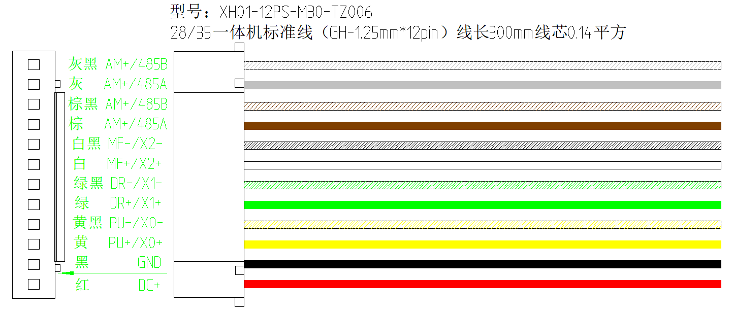
Figure 6.2IDH28Series wiring diagram

Warranty and after-sales

7.1 Warranty

7.1.1 Free warranty
Our company solemnly promises that for all products purchased from our company, if they are damaged due to the product itself during use, we will provide one year of free repair service. The round-trip shipping cost of the product shall be borne by both parties in half.

7.1.2 Warranty exclusion
- The driver is damaged due to the customer's own wiring error;
- The drive is damaged due to exceeding the rated working voltage;
- The DC power supply driver is connected to the AC power supply, causing the driver to be damaged;
- The driver is damaged due to the customer's extremely harsh on-site environment, such as humidity, extreme cold, extreme heat, etc., without informing our company in advance;
- The customer dismantles the drive housing without permission or the serial label number is torn off;
- 15 days after the customer confirms receipt, the housing is obviously damaged or hit, resulting in damage to the drive;
- Forceful natural disasters, such as fire, earthquake, tsunami, typhoon, etc.;
In the above cases, our company will charge a certain amount of repair cost after evaluating the interests of all parties. In other cases, repairs will be provided free of charge forever.

7.2 Exchange

7.2.1 Replacement of defective product
For faults in new products, our company provides three months of free replacement service.
After our technical support staff confirms that the problem is with the product itself, they will send the product back to our company to avoid wasting time and postage on the round trip. Customers need to send the faulty product back by express or logistics first, and our company will send another new product back to the customer as soon as possible after receiving it.
Notice:All our products undergo rigorous testing and aging before leaving the warehouse, so it is extremely rare for new products to malfunction. Please be sure to read the instructions carefully or consult our technical support staff when operating, or our technical support staff will remotely assist customers in operating.
- Please note the following points when exchanging goods:
- Please ensure that the packaging is complete when sending back to avoid damage during transportation;
- Please ensure that the attached accessories are complete when exchanging;
- Each driver should be packed in its original box to avoid secondary damage to the product during transportation;
- If after the driver is sent back, it is confirmed that the failure is not due to product failure, but due to the customer's negligence in operation, which leads to mistakenly thinking that the driver is faulty, the company will not bear the shipping fee (the customer's negligence in operation includes: damage to the driver due to wrong wiring, poor wiring leading to mistakenly thinking that the driver is damaged, operation errors causing the driver to fail to work properly, etc.).

7.2.2 Exchange for non-product failure
If the customer is not satisfied with the appearance or function of the product received and wants to replace it with a better driver, he or she can apply for a replacement service from our company within one week of receiving the product. After verification, our company will return the product. If the returned product is confirmed to be undamaged, with complete accessories and good packaging, the company will replace it with another product for the customer. For the replaced product, if there is a price difference, the customer will make up the difference.
Note: The replaced product will no longer be eligible for the non-product fault replacement service. The round-trip shipping costs and other costs incurred by the non-product fault replacement service shall be borne by the customer!

7.3 Returns
Our company provides a 7-day return service for products with quality problems. If you find quality problems with the product within 7 days of receiving the product (based on the actual date of receipt by the customer), please communicate with our salesperson or technical support personnel in time. After our technical support personnel confirms that it is a quality problem of the company's product itself, the customer can send the original complete product and its inner and outer packaging, accessories and shipping order back to our company by express or logistics.
If the customer still insists on returning the goods after our company has checked and confirmed that they are correct, the round-trip shipping costs and all other costs incurred shall be borne by the customer.
- Please note the following points when returning goods:
(1) Please contact the relevant department of our company before making a refund;
(2) The product must be in new condition and intact packaging. Please send it back to our company by express or logistics;
(3) We will not accept any complaints caused by customers, such as product appearance damage, incomplete accessories, etc.

7.4 After-sales service
If you need after-sales service support when using this product, please contact our company as soon as possible.
National free service hotline: 0755-23206995;
Technical specialist service hotline: 18576758897 (Mr. Xie), 17666115681 (Mr. Tuo);
Service hours: 8:30-17:30, Monday to Friday (except national holidays).

Revision History
Version Number | illustrate | Modify deadline | Preparer/Reviewer
V1.0.0 | Initial use version; | 2024.06.28 | TCJ/XH

